Edwin Ward Moore Squadron
Texas Navy Association

April 10, 2016

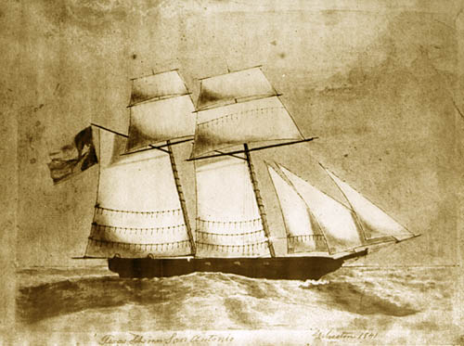
San Antonio Schooner-of-War

Texas Land & Cattle Restaurant
6007 North IH-35
Austin, TX 78723

Pledge to U.S. Flag

“I pledge allegiance to the Flag of the United States of America and to the Republic for which it stands, one Nation under God, indivisible, with Liberty and Justice for all.”

Pledge to Texas Flag

“Honor the Texas Flag; I pledge allegiance to thee, Texas, one state under God, one and indivisible.”

E. W. Moore Squadron Mission

The Edwin Ward Moore Squadron mission is to bring together in fellowship individuals interested in preserving and disseminating the history of the Texas Navy, and to promote awareness of the Texas Navy’s crucial importance during the Texas Revolution and the years of the Republic.

1300 ~ Call to Order – Admiral Wayne Courreges

Opening Ceremony – Admiral Mike Young

Invocation - Admiral Gordon Kelso

Recognition of Guests: Admiral Wayne Courreges

Announcements - Admiral Wayne Courreges

Washington on the Brazos Event –
Admiral Larry Schroeder

French Legation Event – Admiral Karen Thompson

Executive Officer Report – Admiral Andy Barkley

Financial Officer Report – Admiral Hugh Hornsby

Liaison Officer Report – Admiral Tom Hauser

Chaplain Report – Admiral Gordon Kelso

Induction Ceremony – Admiral Wayne Courreges

Admiral Hugh Hornsby

Squadron Bylaws Acceptance – Review & Vote

Introduction of Guest Speaker - Admiral Mike Young

Judge John Powers

1500 - Departure

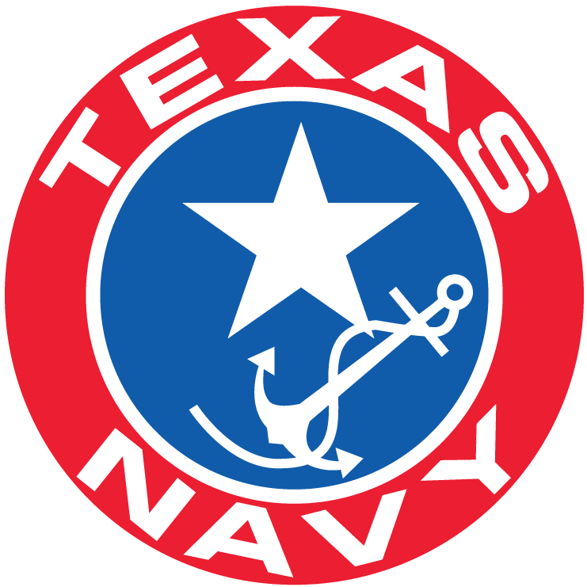

E. W. Moore Squadron

2016-2017 Officers

Commander
Admiral Wayne Courreges

Deputy Commander
Admiral Mike Young

Executive Officer
Admiral Andy Barkley

Financial Officer
Admiral Hugh Hornsby

Texas History Liaison Officer
Admiral Tom Hauser

Sergeant-at-Arms
Admiral Steven S. von Roeder

Chaplain
Admiral Gordon Kelso

Past Commander
Admiral Larry Schroeder

TNA Board Delegate
Admiral Karen Thompson

